The following page(s) is provided so that you can use your preferred translation of the memory verse. Refer to the PDF version of this Activity Page to get an idea of how the text is laid out and arranged. Then use these pages to insert text and create an identical version of the Activity Page, using your preferred Bible translation.
WHAT TO DO:
Print on colored cardstock and cut apart. Make one set for each small group.

Serving Straws Verse Cards—Editable
February 2019, Week 4, Preteen Small Group
©2018 The reThink Group, Inc. All rights reserved.

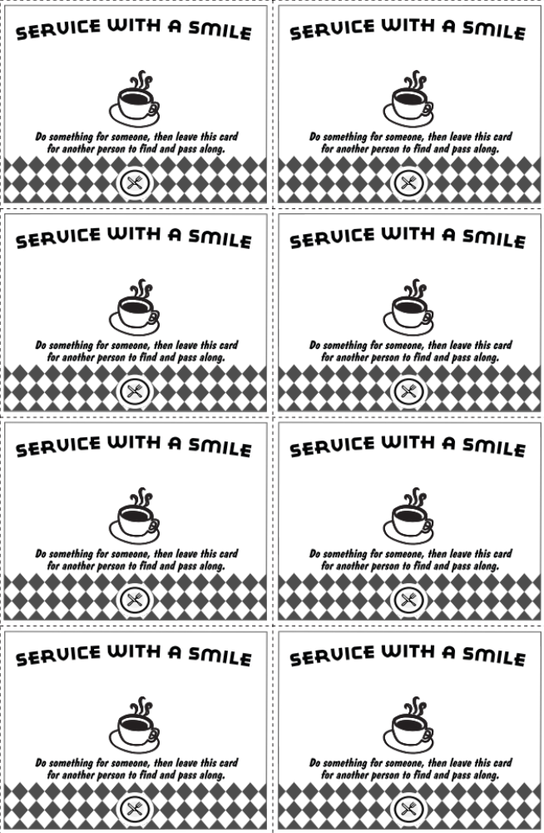

Type here

Type here

Type here

Type here

Type here

Type here

Type here

Type here

