The following page(s) is provided so that you can use your preferred translation of the memory verse. Refer to the PDF version of this Activity Page to get an idea of how the text is laid out and arranged. Then use these pages to insert text and create an identical version of the Activity Page, using your preferred Bible translation.
WHAT TO DO:
Print on different colors of paper (one color for every two kids), cut apart, and save the blank piece. Provide one set for every two kids.

Bible Bits—Editable
January 2020, Week 1, Small Group K1
©2019 The reThink Group, Inc. All rights reserved.

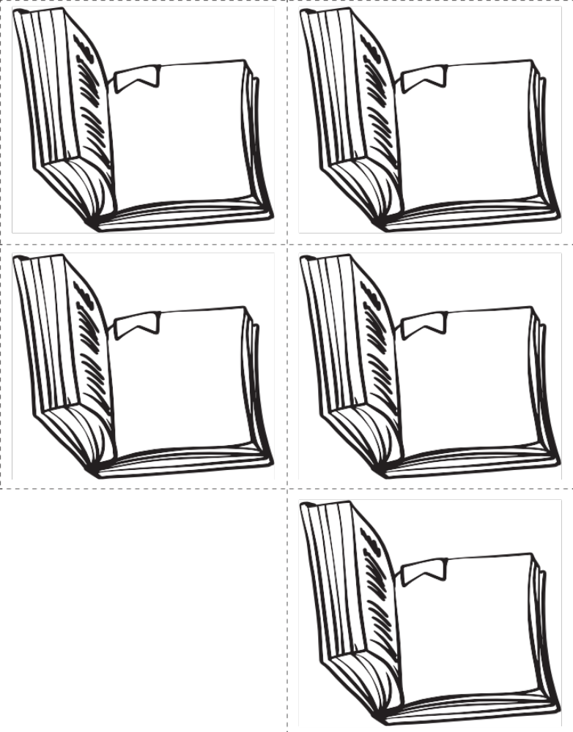

Type here

Type here

Type here

Type here

Type here

